Check for even or odd

<https://github.com/fabricesoffack/Python-codes.git>

For odd number

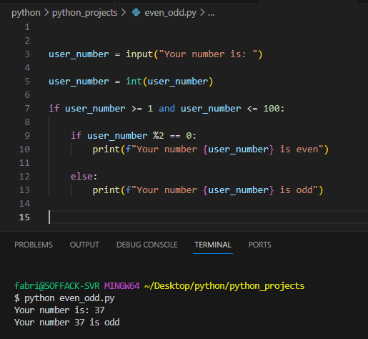

For even number

